Step 1: Download and Compile Latest Fuse

FUSE-2.9.7
http://www.linuxfromscratch.org/blfs/view/svn/postlfs/fuse.html
sudo yum install gcc gcc-c++ openssl-devel libstdc++-devel curl-devel libxml2-devel mailcap
# cd /tmp/
# wget https://github.com/libfuse/libfuse/releases/download/fuse-2.9.7/fuse-2.9.7.tar.gz
# tar -xzf fuse-2.9.7.tar.gz
# cd fuse-2.9.3
# ./configure --prefix=/usr/local
# make
# sudo make install
# export PKG_CONFIG_PATH=/usr/local/lib/pkgconfig
# sudo ldconfig
# sudo modprobe fuse

Step 2: Download and Compile Latest S3FS

S3FS:
https://github.com/s3fs-fuse/s3fs-fuse

Installation
Ensure you have all the dependencies:
On Ubuntu 14.04:
sudo apt-get install automake autotools-dev g++ git libcurl4-gnutls-dev libfuse-dev libssl-dev libxml2-dev make pkg-config
On CentOS 7:
sudo yum install automake fuse fuse-devel gcc-c++ git libcurl-devel libxml2-devel make openssl-devel
Compile from master via the following commands:
git clone https://github.com/s3fs-fuse/s3fs-fuse.git
cd s3fs-fuse
./autogen.sh
./configure
make
sudo make install

Step 3: Setup Access Key
Also In order to configure s3fs we would required Access Key and Secret Key of your S3 Amazon account. Get these security keys from Here.
# echo AWS_ACCESS_KEY_ID:AWS_SECRET_ACCESS_KEY > ~/.passwd-s3fs
# chmod 640 ~/.passwd-s3fs
Note: Change AWS_ACCESS_KEY_ID and AWS_SECRET_ACCESS_KEY with your actual key values.

Step 4: Mount S3 Bucket
Finally mount your s3 bucket using following set of commands. For this example, we are using s3 bucket name as mydbbackup and mount point as /s3mnt.
# mkdir /tmp/cache
# mkdir /s3mnt
# chmod 777 /tmp/cache /s3mnt

# s3fs -o use_cache=/tmp/cache mydbbackup /s3mnt

touch /etc/passwd-s3fs && chmod 640 /etc/passwd-s3fs && echo 'AccessKey:SecretKey' > /etc/passwd-s3fs

Create the mount location, and mount the S3 bucket
Hide Copy Code
root@ip-xxx-xxx-xxx-xxx:~# mkdir -p /mnt/ftp
root@ip-xxx-xxx-xxx-xxx:~# /usr/bin/s3fs -o allow_other -o
default_acl="public-read" -o use_rrs=1 <your_bucket_to_be_mounted> /str/ftp
- Note 1: The bucket must exist before mounting.
- Note 2: the default_acl settings will set everything to public read. For acl options please see the s3fs man pages.
- Note 3: use_rss will set everything that is uploaded to reduced_redundancy (which will save you some money!)

FTP:

Step #1: Install vsftpd
SSH to your EC2 server. Type:
> sudo yum install vsftpd
This should install vsftpd.

Step #2: Open up the FTP ports on your EC2 instance
Next, you'll need to open up the FTP ports on your EC2 server. Log in to the AWS EC2 Management Console and select Security Groups from the navigation tree on the left. Select the security group assigned to your EC2 instance. Then select the Inbound tab, then click Edit:
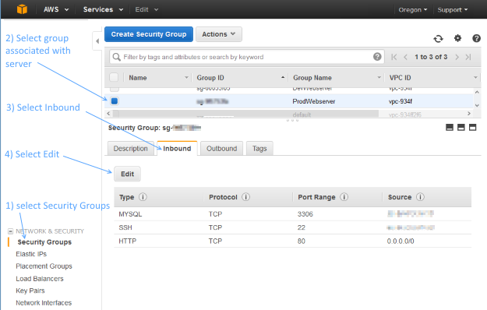
Add two Custom TCP Rules with port ranges 20-21 and 1024-1048. For Source, you can select 'Anywhere'. If you decide to set Source to your own IP address, be aware that your IP address might change if it is being assigned via DHCP.
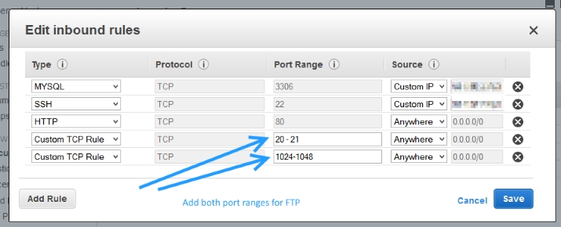

Step #3: Make updates to the vsftpd.conf file
Edit your vsftpd conf file by typing:
> sudo vi /etc/vsftpd/vsftpd.conf
Disable anonymous FTP by changing this line:
anonymous_enable=YES
to
anonymous_enable=NO
Then add the following lines to the bottom of the vsftpd.conf file:
pasv_enable=YES
pasv_min_port=1024
pasv_max_port=1048
pasv_address=<Public IP of your instance>
Your vsftpd.conf file should look something like the following - except make sure to replace the pasv_address with your public facing IP address:
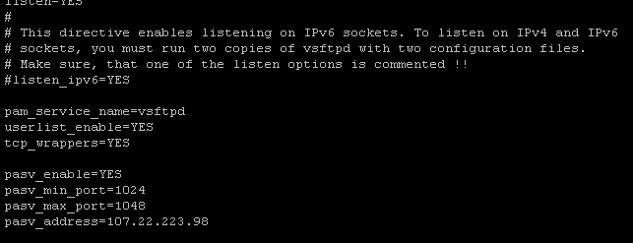
To save changes, press escape, then type :wq, then hit enter.

Step #4: Restart vsftpd
Restart vsftpd by typing:
> sudo /etc/init.d/vsftpd restart
You should see a message that looks like:
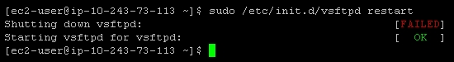
If this doesn't work, try:
> sudo /sbin/service vsftpd restart

Step #5: Create an FTP user
If you take a peek at /etc/vsftpd/user_list, you'll see the following:
# vsftpd userlist
# If userlist_deny=NO, only allow users in this file
# If userlist_deny=YES (default), never allow users in this file, and
# do not even prompt for a password.
# Note that the default vsftpd pam config also checks /etc/vsftpd/ftpusers
# for users that are denied.
root
bin
daemon
adm
lp
sync
shutdown
halt
mail
news
uucp
operator
games
nobody
This is basically saying, "Don't allow these users FTP access." vsftpd will allow FTP access to any user not on this list.
So, in order to create a new FTP account, you may need to create a new user on your server. (Or, if you already have a user account that's not listed in /etc/vsftpd/user_list, you can skip to the next step.)
Creating a new user on an EC2 instance is pretty simple. For example, to create the user 'bret', type:
> sudo adduser bret
> sudo passwd bret
Here's what it will look like:
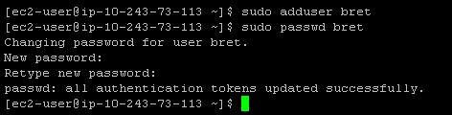

Step #6: Restricting users to their home directories
At this point, your FTP users are not restricted to their home directories. That's not very secure, but we can fix it pretty easily.
Edit your vsftpd conf file again by typing:
> sudo vi /etc/vsftpd/vsftpd.conf
Un-comment out the line:
chroot_local_user=YES
It should look like this once you're done:
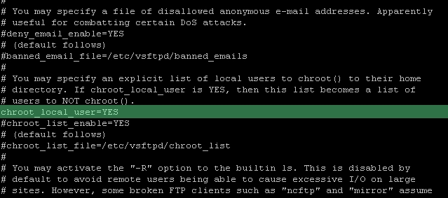
Restart the vsftpd server again like so:
> sudo /etc/init.d/vsftpd restart
All done!

Appendix A: Surviving a reboot
vsftpd doesn't automatically start when your server boots. If you're like me, that means that after rebooting your EC2 instance, you'll feel a moment of terror when FTP seems to be broken - but in reality, it's just not running!. Here's a handy way to fix that:
> sudo chkconfig --level 345 vsftpd on
Alternatively, if you are using redhat, another way to manage your services is by using this nifty graphic user interface to control which services should automatically start:
> sudo ntsysv
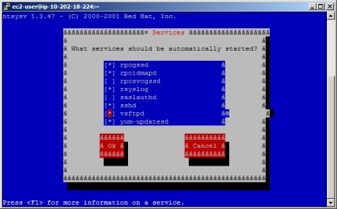
Now vsftpd will automatically start up when your server boots up.

Appendix B: Changing a user's FTP home directory
* NOTE: Iman Sedighi has posted a more elegant solution for restricting users access to a specific directory. Please refer to his excellent solution posted as an answer *
You might want to create a user and restrict their FTP access to a specific folder, such as /var/www. In order to do this, you'll need to change the user's default home directory:
> sudo usermod -d /var/www/ username
In this specific example, it's typical to give the user permissions to the 'www' group, which is often associated with the /var/www folder:
> sudo usermod -a -G www username

Configure SSL with vsftpd
The first step towards getting vsftpd to operate with SSL is to create our SSL certificate. We will actually be using TLS, which is a protocol that is a successor to SSL and more secure.
We will create a subdirectory within the SSL directory to store our files:
sudo mkdir /etc/ssl/private
To create the certificate and the key in a single file, we can use this command:
openssl req -x509 -nodes -days 365 -newkey rsa:1024 -keyout /etc/ssl/private/vsftpd.pem -out /etc/ssl/private/vsftpd.pem
Fill out the questions that it asks. The most important being the "Common Name" of your server, which will be the IP address or domain name that you will use to connect.

Add the SSL Details to the vsftpd Configuration File
Now, we need to alter our configuration to point to the new keys and configure the secure connection.
Open the vsftpd configuration file as root again:
sudo nano /etc/vsftpd/vsftpd.conf
Scroll to the bottom of the file. We will add our SSL/TLS information here.
We need to specify the location of our certificate and key files. We actually combined both pieces of information into a single file, so we will point both options to the same file:
rsa_cert_file=/etc/ssl/private/vsftpd.pem
rsa_private_key_file=/etc/ssl/private/vsftpd.pem
Next, we need enable the use of these files and disable anonymous users. We should also force the use of SSL for both data transfer and login routines. This will make the security mandatory:
ssl_enable=YES
allow_anon_ssl=NO
force_local_data_ssl=YES
force_local_logins_ssl=YES
Next, we will restrict the type of connection to TLS, which is more secure than SSL. We will do this by explicitly allowing TLS and denying the use of SSL:
ssl_tlsv1=YES
ssl_sslv2=NO
ssl_sslv3=NO
We'll add a few more configuration options before finishing:
require_ssl_reuse=NO
ssl_ciphers=HIGH
Save and close the file.
We need to restart vsftpd to enable our changes:
sudo /etc/init.d/vsftpd restart
We will also configure it to start automatically with every reboot:
sudo chkconfig vsftpd on

